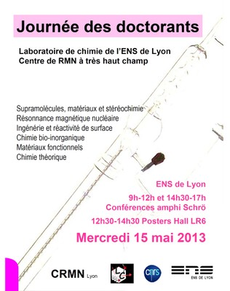
PhD day 2013

09h00 - 09h05 Opening session (Chantal or Lyndon)

09h05 - 09h25 Guillaume GROS Modular construction of N-CO-interacted inhibitor candidates and their biological assessment with HIV-1 protease
09h25 - 09h45 Aline SCHMITT Stereoselective recognition of glucopyranosides and chiral neurotransmitters by enantiopure hemicryptophanes
09h45 - 10h05 Alexandre ZAGDOUN Dynamic Nuclear Polarization Surface Enhanced NMR Spectroscopy.
10h05 - 10h25 Gwenaelle EUCAT Design of solid state emitters for biological imaging

10h25 - 10h50 Coffee Break

10h50 - 11h10 Yuting ZHENG Quantitative UV-visible Investigation of Vanadium Dispersion in Al or Ti modified MCM-41Silicas
11h10 - 11h30 Simon PASCAL Two-photon absorption in the near-infrared region: towards bio-imaging applications.
11h30 - 11h50 Jérémie ZAFFRAN Fast prediction of polyols reactivity at metallic surfaces

11h50 12h15 Flash presentation of posters (2 min per poster)
Torsten HOUWAART CoTPP adsorption on coinage metals and comparison of calculated STM images
Chandan PATEL Complex DNA lesions : Insights from QM/MM—MD.
Romain RAMOZZI Ugi-type reactions: a never ending source of innovation
Yuemei SUN The influence of H-adatoms on H₂ dissociation on Pd(111) at finite coverages
Oliver THORN-SESHOLD Development of Auto-Immolative Spacers for Probes of Enzyme Activity
Bastien CHATELET Superbases in the confined space of hemicryptophane hosts: control of the basicity and influence on the reactivity of the proton transfer …/…
Denis CHÂTEAU Design of efficient monolithic hybrid materials for optical protection
Damia GREGORI Composite coatings with photocatalytic properties obtained by the sol-gel process on flexible materials
Jérémy CHAIGNON Silica-grafted manganese complexes for catechol oxidation
Anne FAGES A NMR metabonomic approach to explore early biomarkers of Hepatocellular Carcinoma in the European Prospective Investigation into Cancer and Nutrition
Elodie JOBARD NMR Metabonomic Investigation of Early Biomarkers of Breast Cancer in the E3N Prospective Cohort

12h15 - 14h15 Lunch break with Poster discussions (LR6)

14h15 - 14h35 Maxime PROST Sondes fluorogènes pour l’imagerie à très haute sensibilité de l’activité enzymatique
14h35 - 14h55 Raymond GRÜBER The good choice of a functional : is the best the enemy of the good ?
14h55 - 15h15 Laure-Lise CHAPELLET Structural modifications of the cryptophanes: towards new types of biosensors

15h15 - 15h40 Coffee Break

15h40 - 16h00 Bastien METTRA Molecular engineering of two photons absorbing chromophores. Towards understanding of the excited state photophysics.
16h00 - 16h20 Jinping WANG Achieving electroneutrality in low-spin iron(II) complexes that respond to chemical reactants
16h20 - 16h40 Martin IPUY Synthesis of new pH sensitive fluorescent probes based on the TCF electron accepting group

16h40 - 17h00 Closing session (Evaluation and conclusion)

